Elias work during Sprint 4

Spend the night of 10/30/19 working to make a local database to make at least any type of demo. But for some reason I couldn’t connect the solution on the github to my local database. 14 hours

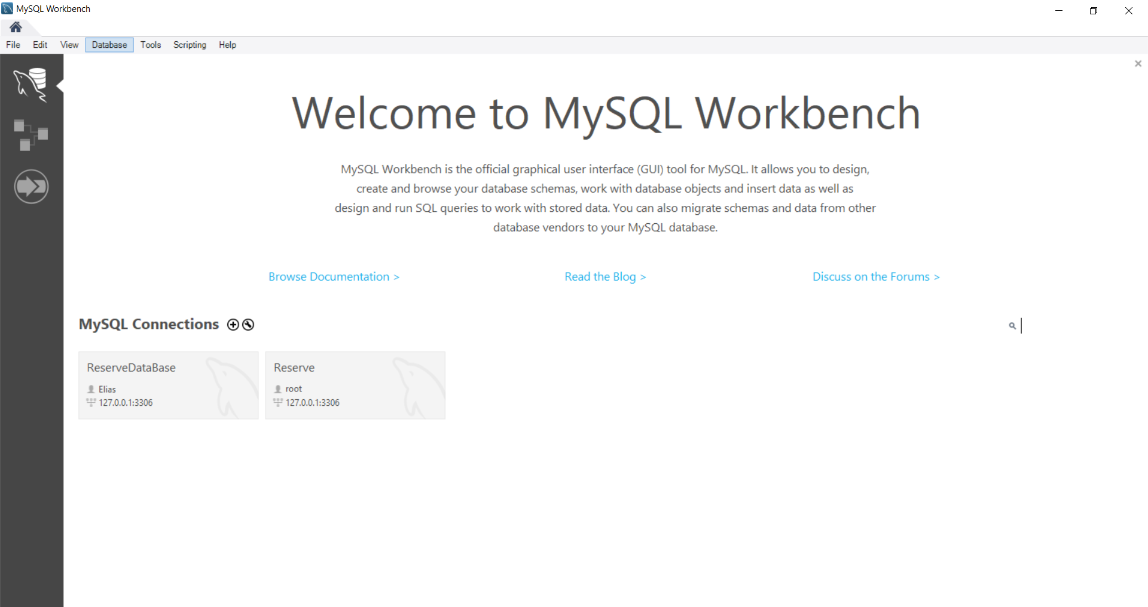

Also, I implemented the aspx pages from the old solution to the new one on GitHub. Made sure that the pages have same code and HTM. took me 10 hours

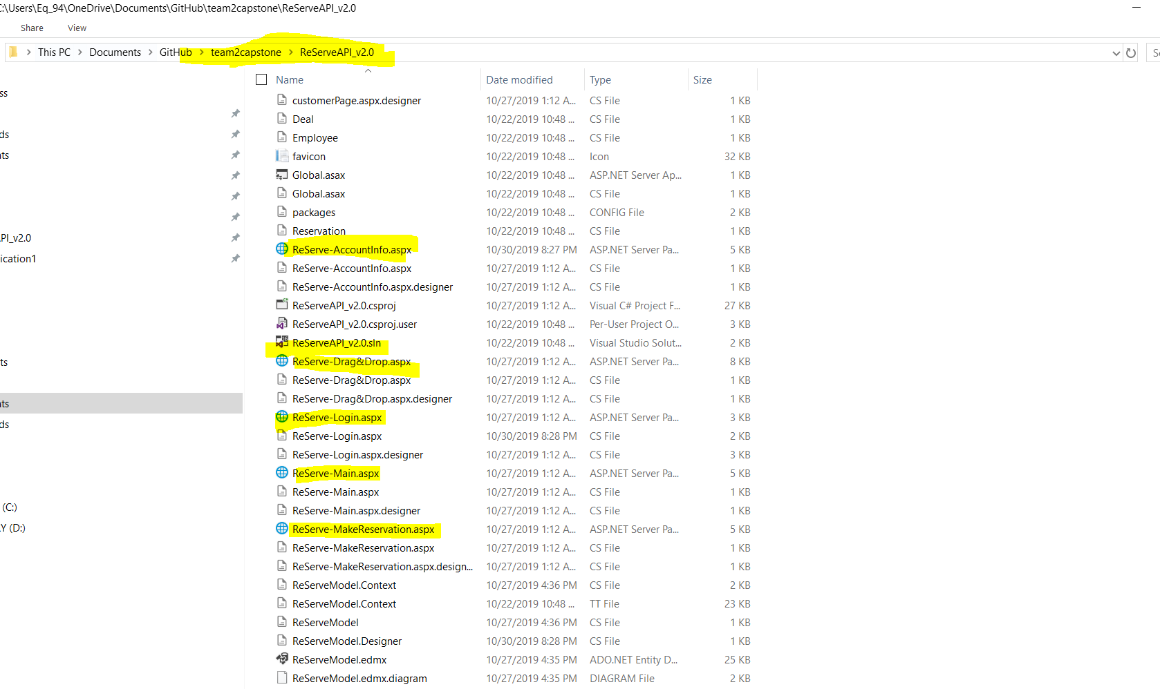

Spend 4 hours in meeting with the team and 1 hours planning and writing the Presentation PowerPoint